**OBJECTIVES**

By the end of this module, you should be able to:

* Know what objectives are and be able to phrase them clearly
* Scale objectives appropriately to the decision context
* Classify objectives: strategic, fundamental, means, process
* Build an objectives hierarchy
* Develop measurable attributes (performance metrics)

**DETERMINING OBJECTIVES**

* Objectives are what you really care about
* Well defined objectives are critical in order to:
* Create alternatives
* Compare alternatives
* Choose pertinent information
* Evaluate performance
* Explain your decision to others
* All structured decision steps build from objectives
* Objectives are NOT targets
* Target = a desired level of performance towards an objective
* “Restore 500 hectares of riparian habitat” is a target
* “Maximize marshbird abundance” is an objective
* In SDM we treat targets as alternatives and compare their performance against objectives

***Steps for creating good objectives***

1. Articulate concerns and wishes (‘desired future conditions’)
2. Convert concerns to objectives
3. Structure objectives
   * Classify objectives
   * Distinguish fundamental and means objectives
   * Create an objectives hierarchy
4. Create measurable attributes for each objective
5. Review for completeness

***Qualities of good objectives (from Keeney 2007, pg. 117)***

* **Complete** – All of the important consequences of alternatives in a decision context can be adequately described in terms of objectives. That is, the objectives must be sufficient to evaluate all the alternatives under consideration.
* **Non‐redundant** – the fundamental objectives should not include overlapping concerns
* **Concise** – The number of objectives should be the minimum appropriate for quality analysis
* **Specific** – each objective should be specific enough so that consequences of concern are clear and attributes can readily be selected or defined
* **Understandable** – any interested individual knows what is meant by the objectives. Both the action and preferred direction of change are apparent.

***Don’t get hung‐up on objectives jargon***

* Minimize = less of something
* Maximize = more of something

**GENERATING OBJECTIVES**

* Generating a complete list of objectives is challenging, especially on a single try. So, plan on iterating (trying over and over) until new objectives do not come up.
* Bond et al. (2008) Example:
* Participants were introduced to an important decision of personal significance (e.g., selection of an MBA program)
* Participants were instructed to list their objectives
* Participants then were shown a masterlist of objectives and asked to check relevant objectives
* The Result: The participants consistently omitted nearly half of the objectives that they later identified as relevant. More surprisingly, omitted objectives were perceived to be almost as important as (*self‐generated objectives)*

**CLASSIFY OBJECTIVES**

Keeney (2007) described four kinds of objectives:

* **Fundamental:** the basic reason for caring about the decision (essential)
* **Means:** influence the achievement of fundamental objectives (substitutable; not necessarily essential)
* **Process:** concerns *how* the decision is made rather than *what* decision is made
* **Strategic:** highest level or ultimate-end objectives. All objectives of a particular decision context must be means to achieving strategic objectives

***Process Objectives***

* *“…especially in public decisions made by government, both what is chosen and how the alternative is chosen are important. In other words, the* process *of decision‐making in these situations matters…” (Keeney 2007)*
* Recognize differences between *what* the decision is and *how* it is made
* Example process objectives:
* *Increase intra‐agency cooperation*
* *Increase transparency in decision making*
* *Maximize tribal involvement*

What examples of Process Objectives might you encounter in your work?

***Strategic Objectives***

* Should guide *all* decisions → The separate decisions made over time are the means by which strategic objectives are pursued.
* Collectively determine overall performance of an organization or individual
* Are often too vague to be useful for any given decision context
* Clearly defining strategic objectives establishes a sound basis for decision making that can repeatedly be used for subsequent decision making
* These are objectives that might not make sense if the decision in question was being made in isolation, but they make sense when considering the whole set of decisions that a decision‐maker or agency needs to make
* Examples of strategic objectives
* For an individual: *Maximize my quality of life*
* For a natural resource stewardship agency:
* *Maximize the structure and function of aquatic and terrestrial resources*
* *Act consistently with the public’s environmental values*
* *Maximize contribution to quality of life in the US*
* *Increase public trust in the agency*
* *Develop long‐term partnerships*
* *Demonstrate good stewardship of tax dollars*

What examples of Strategic Objectives might you encounter in your work?

*Strategic vs. fundamental decision contexts*

* Strategic objectives are the ultimate objectives of a decision maker
* All non‐strategic objectives must be means objectives to strategic objective
* The purpose of any decision is (ultimately) to contribute to the achievement of strategic objectives
* It is rare to focus decisions at the level of the Strategic Objectives, so the *Fundamental Decision Context* is generally encapsulated by the *Strategic Decision Context*
* Fundamental objectives should be developed at the level of the *Fundamental Decision Context*
* Developing fundamental objectives at the scale of the Strategic Decision Context can lead to the development of objectives that fall outside of the scope of the Fundamental Decision Context

Fundamental Objectives

* Must be essential
* Relevant to every alternative
* Can’t be substituted
* Must be controllable in this decision context
* Available alternatives will influence this objective
* Not too broad or high‐level to be beyond control
* What is considered to be “fundamental” is dependent on the decision context
* Examples of fundamental objectives
* *Maximize the probability of persistence of brown bears*
* *Minimize human‐bear conflicts in the Arctic National Park Network*
* *Maximize non‐consumptive use activities*
* Possible traits of fundamental objectives
* **Conflicting Objectives** – Fulfillment of one objective is in direct conflict with another
* *Example:*
* **Linked Objectives** – One objective must be fulfilled before a second objective can be fulfilled. The second objective is linked to the first.
* *Example:*
* **Hidden Objectives** – Objectives that are obscured by the complexity of the decision or are intentionally obscured by a party to the decision
* *Example:*

* **Stranded Objectives** ‐ Fundamental objectives that have no connection to means objectives, and thereby no means of fulfillment. Stranded objectives indicate that the scope of the problem has been too narrowly or broadly defined
* *Example:*
* Identifying these traits can help with identifying the decision class
* Conflicting → Multiple Objective or Portfolio
* Linked → Dynamic
* Identifying these traits can help with problem framing:
* Hidden → If objectives are being intentionally obscured by a party to the decision, the problem may fall outside of the SDM decision space (i.e., and into conflict, governance, or competitive games)
* Stranded → Has the scope been too narrowly or broadly defined. Can the support of missing decision makers and/or implementers be garnered to gain a means of fulfilling stranded objective? Or does the scope of the problem need to be narrowed?

***Means Objectives***

* Means objectives are not desired for themselves
* They help accomplish fundamental objectives
* They are substitutable for other means objectives
* Treating means objectives as fundamental can:
* unnecessarily limit the range of alternatives considered
* reduce the likelihood of achieving what’s truly important
* lead to skewed weighting of the objectives.

***Distinguish Means and Fundamental Objectives***

* Ask: Is this where I want to go (= fundamental), or is it a way to get there (=means)?
* You know you have reached a fundamental objective when the answer to the question, “Why is that important?” is:
* “Just because,” “It’s the law,” “because it’s simply important,” “because it has inherent value,” etc…
* To find means of achieving fundamental objectives, ask:
* How can I address this concern?
* How can I measure success?
* How can I make the stakeholders happy?

**DEVELOPING OBJECTIVES HIERARCHIES**

* Fundamental objectives are specific to the decision context. A different decision context (say, now from the perspective of a regulatory agency rather than an environmental NGO) may require a different hierarchy
* Building objectives hierarchies, or ends‐means networks, will help identify controllable objectives and may lead to the identification of alternatives

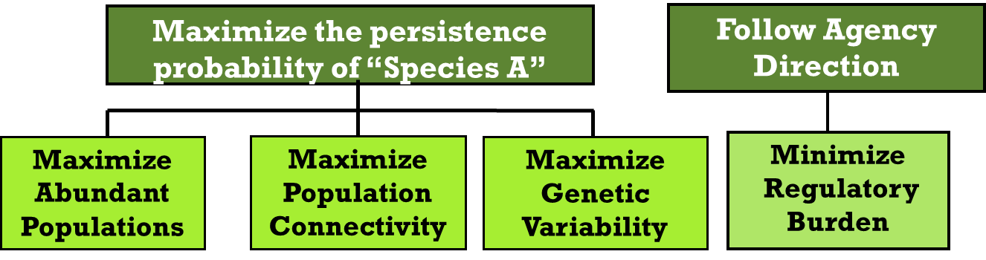

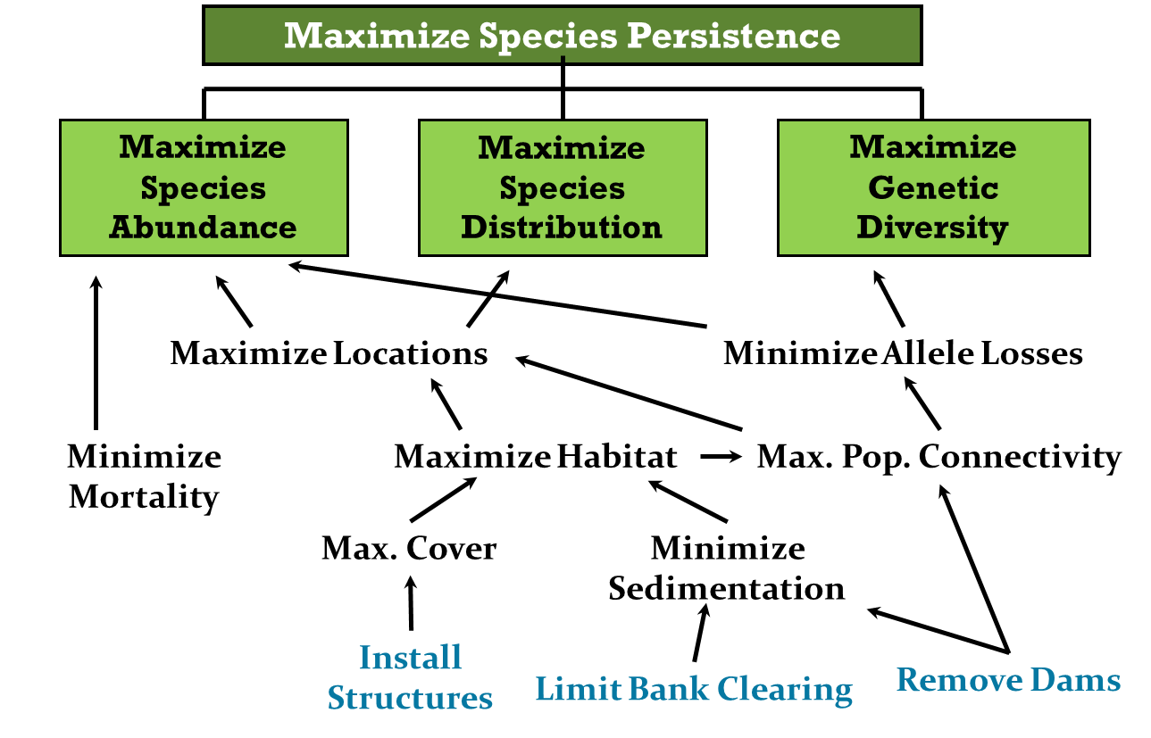

* Stranded objectives may be revealed when there is no means to fulfill a particular objective. This happens most frequently when the objective falls outside of the decision scope. The decision may be broadened (if possible) or the objective may need to be dropped from the decision at hand.

**Maximize Habitat**

**Regulate Subsistence harvest**

**Reduce predators**

**Minimize Mortality**

**Max. Pop. Connectivity**

**Minimize Allele Losses**

**Maximize Locations**

**Maximize Species Persistence**

**Maximize**

**Species Abundance**

**Maximize Species Distribution**

**Maximize**

**Genetic Diversity**

**DEVELOP MEASURABLE ATTRIBUTES**

* Attributes are how you measure performance
* Attributes should be developed for *fundamental* objectives that are at the *lowest* level of the objectives hierarchy.

*Attribute = Performance Measure = Criterion*

* An attribute should include:
* Content (what you’ll measure)
* Preferred direction of the measured content
* The aspiration:
* maximize (or minimize)
* a threshold
* a particular level of change
* An attribute is used to:
* Predict how a given decision will lead to measurable objective outcomes
* Compare realized objective outcomes to predicted outcomes after decision implementation

|  |  |  |  |
| --- | --- | --- | --- |
| **Objective** | **Direction** | **Aspiration** | **Attribute** |
| **Minimize costs** | **↓** | **Minimize** | **M$/yr** |
| **Maximize occupancy rate** | **↑** | **Maximize** | **Probability (0-1)** |
| **Minimize extinction probability** | **↓** | **Minimize** | **Probability (0-1)** |
| **Maximize harvest user satisfaction** | **↑** | **Maximize** | **Harvest Success Rate**  **(# harvested/#permits)** |

Measurable attributes (Keeney and Gregory 2005) should be:

* **Unambiguous** – Clear relationship between consequences and levels of attribute
* **Direct** – Clearly related to objective of interest
* **Comprehensive** – Cover the full range of possible consequences
* **Operational** – Suitable information available
* **Understandable** – Readily understood and easily communicated

Three types of attributes:

1. Natural attributes – the object can be directly measured
2. Constructed attributes – characterized by a sliding or relative scale that requires interpretation
3. Proxy attributes – a natural attribute that is highly correlated with the objective but does not directly measure it

*Natural Attribute Examples*

Minimize employee absence from work due to illness: # of sick days

Maximize visitor center revenue: $ of sales

Maximize reproductive success: # of fledglings

*Constructed Attribute Examples*

Example: Minimize wetland development impacts: The impacts of development projects can be rated using a scale of 0 to 5 (described below), with 5 being the greatest impact.

**0** No loss of riparian areas and ≥ 300 acres estuary restored

**1** No loss of riparian areas and < 300 acres estuary restored

**2** No loss of riparian areas and no loss of estuary

**3** Loss of < 300 acres riparian area and < 300 acres of estuary

**4** Loss of < 300 acres riparian area and ≥ 300 acres of estuary

**5** Loss of ≥ 300 acres riparian area and ≥ 300 acres of estuary

Example: Infant APGAR scores – five factors are evaluated:

1. activity and muscle tone
2. pulse (heart rate)
3. grimace response ("reflex irritability")
4. appearance (skin coloration)
5. respiration (breathing rate and effort)

Each is scored on a scale of 0 to 2 (2 is best).

Scores are added for the total APGAR score; > 7 is a healthy baby.

*Proxy Attribute Examples*

Minimize student boredom: # of yawns

Maximize genetic diversity: % of natural range preserved

Maximize reproductive success: # of acres of nesting habitat

What types of attributes are listed in the Hines dragonfly example?

***constructed***

**(define H, M, L)**

***constructed***

**(define H, M, L)**

***proxy***

***natural***

**Maximize Persistence Probability**

**Maintain HED habitat quality**

**habitat quality**

**prob(extirpation)**

**Maximize # of sites occupied**

**# occupied sites in study area**

**Success Rate**

**H, M, L**

**Maximize long-term subpopulation persistence**

**REFERENCES**

Bond SD, Carlson KA, Keeney RL. 2008. Generating objectives: can decision makers articulate what they

want? Management Science 54:56‐70.

Conroy MJ and JT Peterson. 2013. Decision Making in Natural Resource Management: A Structured

Adaptive Approach. Hoboken, New Jersey, USA: John Wiley and Sons, Ltd.

Keeney RL. 1996. Measuring the achievement of objectives. Pages 45‐46 *in* Keeney RL, editor. Value‐

focused thinking: A path to creative decisionmaking. Cambridge, Massachusetts, USA: Harvard University Press.

Keeney RL. 1996. Value‐focused Thinking: A Path to Creative Decisionmaking. Cambridge,

Massachusetts, USA: Harvard University Press. 432 p.

Keeney RL. 2007. Developing objectives and attributes. Pages 104‐128 *in* Edwards W, Miles RFJ, Von

Winterfeldt D, editors. Advances in decision analysis: from foundations to applications. Cambridge, UK: Cambridge University Press.

Keeney RL, Gregory RS. 2005. Selecting attributes to measure the achievement of objectives. Operations

Research 53:1‐11.

**MODULE DEVELOPED BY:**

Angela Romito, *USFWS Southeastern Regional Office*

Jean Fitts Cochrane, *Consultant (USFWS retired)*

Michael C. Runge, *USGS Patuxent Wildlife Research Center*

Angela Matz, *USFWS Fairbanks Field Office*

Jennifer A. Szymanski, *USFWS Midwest Region*

Suggested Citation for this Module:

Romito AM, Cochrane JF, Runge MC, Matz A, Szymanski JA. 2016. Objectives. Module 5 *in* Runge MC,

Romito AM, Breese G, Cochrane JF, Converse SJ, Eaton MJ, Larson MA, Lyons JE, Smith DR, Isham AF, eds. Introduction to Structured Decision Making, 2016 edition. U.S. Fish and Wildlife Service, National Conservation Training Center, Shepherdstown, West Virginia, USA.